Chew’s Website-Generator - Installation and Usage

Author | Product | Current Version | Platform
Leonard Chew | Chew’s Website-Generator (CWG) | 1.0.1 | Windows
leonard@chew.ch

Table of contents

1 Install the PERL-Interpreter 2
2 PerlMagick 3
3 Usage 4
4 Configuration 5
4.1 Configuration-File ‘config.txt’ 5
4.2 HTML-Templates 5

Install the PERL-Interpreter

If you dont have a PERL-Interpreter installed, install ActivePerl on your PC.

When installing the interpreter, make sure the following two checkboxes are checked:

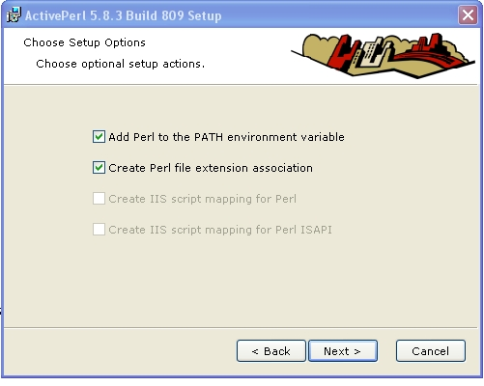

PerlMagick

CWG needs the PerlMagick - Module. This can be installed the hard way, like downloading the module and dependencies from CPANEL (Image::Magick), or by installing the ImageMagick application for windows.

Installing ImageMagick:

All we are interested in is the PerlMagick module.
When installing ImageMagick you MUST check this checkbox
- ‘Install PerlMagick for ActiveState Perl’:

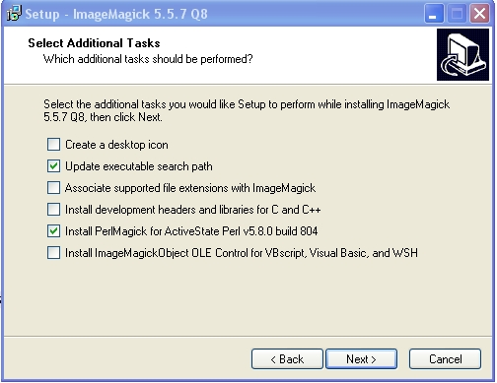

Usage

Chew’s Website-Generator (CGW) is extremely simple to use :-))

- Download CGW from http://www.zilgware.ch/leonard/software/website_generator
- Extract the zip-file into your personal directory.
Important: Include folder structures !
- Create a directory containing pictures (.jpg) and/or movies (.avi)
Note: Prefix the images with numbers to sort them
- Copy the folder ‘website_generator’ into the directory containing your pictures and movies:
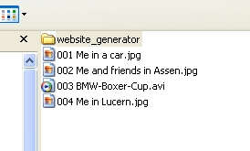
- Open the folder ‘website_generator’ and double-click on ‘generate_website.pl’
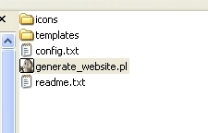
- Your new website is finished! - It is located in the directory of your images and is called ‘Website’.
Open the ‘Website’-folder and doubleclick ‘index.html’ and you will see the result.
The demo-version from above can be seen at:
http://www.chew.ch/leonard/software/website_generator/demo

Configuration

There are some configuration-parameters you can change to your gusto.

Configuration-File ‘config.txt’
The configuration-file ‘config.txt’ contains the variable PERL-parts.
All parameters are MANDATORY, but their values can be changed.

Here is how you manipulate the file.

Parameter | Description of the value | Default
NUMBER_OF_COLUMNS | Defines the maximum number of columns for one thumnail-page. | 5
NUMBER_OF_ROWS | Defines the maximum number of rows for one thumnail-page. | 4
THUMBNAIL_SIZE | Defines the size of the thumbnail-pictures | 100
PIC_SIZE | Defines the size of the internet-pictures | 600
WAIT_TIME | Defines the waiting-time in seconds for the ‘PLAY’-Button | 5
INLCUDE_ORIG | Defines if the original pictures (which can be quite large) should be included to the website.  You can see this picture when clicking on the regular ‘internet-picture’.  For websites on webservers this should be set to ‘FALSE’ (discspace-issue), for local websites it is nicer to set it to ‘TRUE’.  In the demo it is set to ‘TRUE’ | FALSE

HTML-Templates

The HTML-Templates can be modified manually. However these two rules should be observed:
- Do not change the java-script code
- Do not change the ‘TAGs’ which look like ---MY_TAG---
These tags are edited by the PERL script

